
ISTANBUL TECHNICAL
0
1
UNIVERSITY

COMPUTER ENGINEERING

DIGITAL CIRCUITS LABORATORY
EXPERIMENT REPORT

EXPERIMENT NO: 1

EXPERIMENT NAME: BOOLEAN ALGEBRA

EXPERIMENT DATE : 01.03.2013

GROUP NO: 6

STUDENTS WHO DID THE EXPERIMENT:

Student no Name Surname

040100113 MUSTAFA UÇAR
040100117 TUĞRUL YATAĞAN
040100124 EMRE GÖKREM

ASSISTANT NAME WHO ASSISTED THE EXPERIMENT: NAGEHAN İLHAN

Aim: Proving the axioms and theorems of Boolean algebra is the goal of the experiment.

Conclusion:
Experiment #1
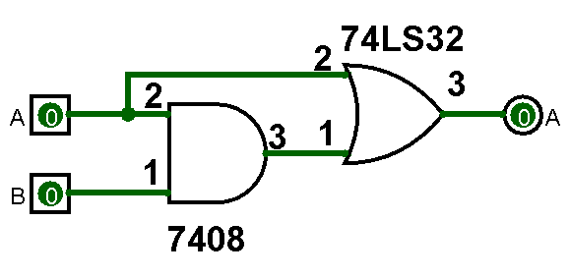
From equation A + A*B = A, it is expected that output will be only depend on input A. Input B won’t change the output value. Here is the result table from this experiment;

A | B | Output
0 | 0 | 0
0 | 1 | 0
1 | 0 | 1
1 | 1 | 1

From equation (A+B).(A+B') = A, same results are expected and obtained.
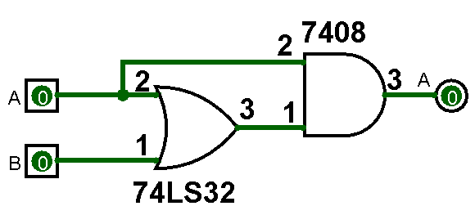
Experiment #2
Dual of the equation A + A.B = A is A.(A + B) = A. Again, it is expected that output will be only depend on input A. Here is the result table from this experiment;
A | B | Output
0 | 0 | 0
0 | 1 | 0
1 | 0 | 1
1 | 1 | 1
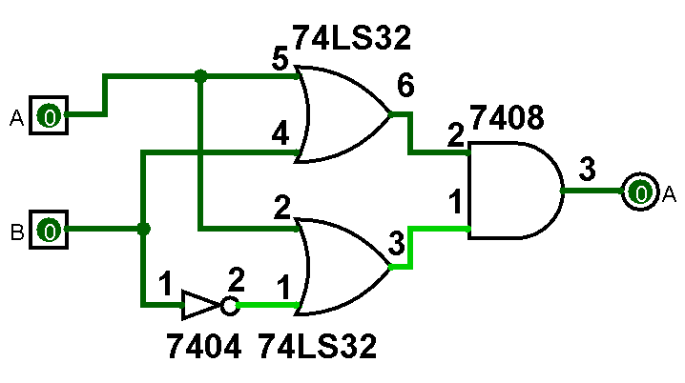

Experiment #3
F’ = X’.(Y’ + Z’) 1 value from X input will make F automatically 0. Otherwise output F will be depending on Y and Z values. Here is the result table from this experiment;

X | Y | Z | F’
0 | 0 | 0 | 1
0 | 0 | 1 | 1
0 | 1 | 0 | 1
0 | 1 | 1 | 0
1 | 0 | 0 | 0
1 | 0 | 1 | 0
1 | 1 | 0 | 0
1 | 1 | 1 | 0

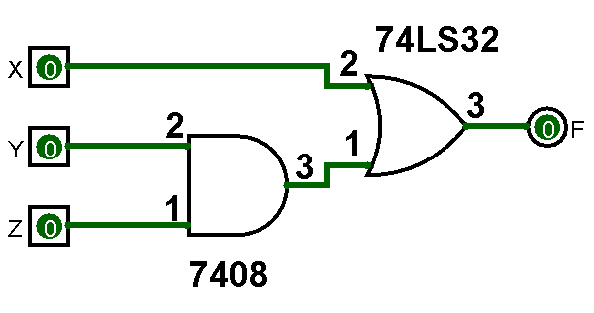
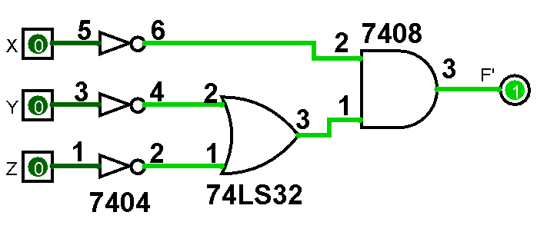

Experiment #4
F(A,B,C,D) = A'.B'.D' + B.C'.D'+AB'D'+BC'D+BCD' is reduced to F(A,B,C,D) = D’ + B’C’ It shows that F is not affected by input A. Here is the truth table from this equation;
A | B | C | F
0 | 0 | 0 | 1
0 | 0 | 1 | 1
0 | 1 | 0 | 1
0 | 1 | 1 | 1
1 | 0 | 0 | 1
1 | 0 | 1 | 0
1 | 1 | 0 | 0
1 | 1 | 1 | 0

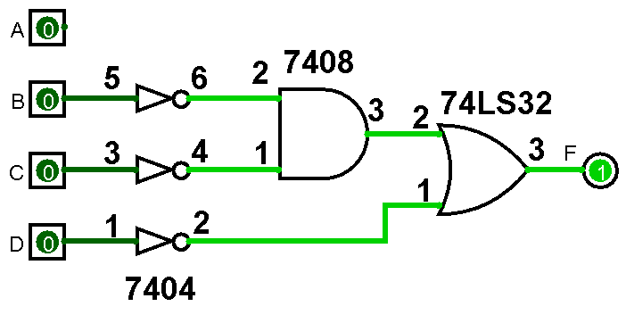

Answer of 3rd Question
This problem is caused by wrong usage of de Morgan’s Law. Operation priority and parenthesis are used wrong.
The right way is:
F(A,B,C,D)= (A+(B.C)+D)’
F(A,B,C,D)=A’.(B.C)’.D’
F(A,B,C,D)=A’.(B’+C’).D’

